Chapter 3
Exercise 1
3.10 Compare and contrast the if single-selection statement and the while repetition statement. How are these two statements similar? How are they different?
Answer:
Similar: both test a condition and run their body only when the condition is true. Both have one entry point and one exit point.
Different: if runs its body at most once. while runs its body again and again as long as the condition stays true, so it can run zero, one or many times. The body of a while must change something that eventually makes the condition false, or the loop never ends.
3.11 Explain what happens when a Java program attempts to divide one integer by another. What happens to the fractional part of the calculation? How can you avoid that outcome?
Answer:
When both operands are integers, Java performs integer division. The fractional part is discarded (truncated), so 7 / 2 gives 3, not 3.5.
To avoid this, make at least one operand floating point, for example with a cast: (double) 7 / 2 gives 3.5. Dividing an integer by zero throws an ArithmeticException.
3.12 Describe the two ways in which control statements can be combined.
Answer:
Stacking: control statements placed one after another, so the exit of one connects to the entry of the next.
Nesting: placing one control statement inside the body of another, for example an if statement inside a while loop.
3.13 What type of repetition would be appropriate for calculating the sum of the first 100 positive integers? What type would be appropriate for calculating the sum of an arbitrary number of positive integers? Briefly describe how each of these tasks could be performed.
Answer:
First 100 positive integers: counter-controlled repetition, because the number of repetitions (100) is known. Set sum to 0 and counter to 1. While counter <= 100, add counter to sum and increment counter.
Arbitrary number of positive integers: sentinel-controlled repetition, because the count is not known in advance. Set sum to 0 and read a value. While the value is not the sentinel (for example -1), add it to sum and read the next value. The sentinel must be a value that cannot be real data.
3.14 What is the difference between preincrementing and postincrementing a variable?
Answer:
Preincrement (++x) adds 1 to x first, then the new value is used in the expression. Postincrement (x++) uses the current value of x in the expression first, then adds 1.
Example with x = 5: y = ++x gives x = 6 and y = 6. y = x++ gives y = 5 and x = 6.
3.15 Identify and correct the errors in each of the following pieces of code. [Note: There may be more than one error in each piece of code.]
a) if (age >= 65);
System.out.println("Age is greater than or equal to 65");
else System.out.println("Age is less than 65)";
b) int x = 1, total;
while (x <= 10) {
total += x; ++x;
}
c) while (x <= 100)
total += x; ++x; d)
while (y > 0) {
System.out.println(y);
++y;
Answer:
a) Errors: the semicolon after the if condition makes an empty body, so the else has no matching if (syntax error). In the else statement the closing quote, parenthesis and semicolon are in the wrong order. Corrected:
if (age >= 65)
System.out.println("Age is greater than or equal to 65");
else
System.out.println("Age is less than 65");

b) Error: total is never initialized, so total += x does not compile. Corrected:
int x = 1, total = 0;
while (x <= 10) {
total += x;
++x;
}

c) Errors: the loop body has no braces, so only total += x is repeated. ++x runs after the loop, x never changes inside it, and the loop never ends. x and total also need to be declared and initialized. Corrected:
int x = 1, total = 0;
while (x <= 100) {
total += x;
++x;
}

d) Errors: the closing brace is missing, and ++y should be --y. With ++y, y keeps growing and the loop never ends. y must also start with a positive value. Corrected:
int y = 5;
while (y > 0) {
System.out.println(y);
--y;
}

Exercise 2
3.17 (Gas Mileage)
Drivers are concerned with the mileage their automobiles get. One driver has kept track of several trips by recording the miles driven and gallons used for each tankful. Develop a Java application that will input the miles driven and gallons used (both as integers) for each trip. The program should calculate and display the miles per gallon obtained for each trip and print the combined miles per gallon obtained for all trips up to this point. All averaging calculations should produce floating-point results. Use class Scanner and sentinel-controlled repetition to obtain the data from the user.
Answer:
import java.util.Scanner;

public class GasMileage {
public static void main(String[] args) {
Scanner input = new Scanner(System.in);
int totalMiles = 0;
int totalGallons = 0;

System.out.print("Enter miles driven (-1 to quit): ");
int miles = input.nextInt();

while (miles != -1) {
System.out.print("Enter gallons used: ");
int gallons = input.nextInt();

if (gallons > 0) {
totalMiles += miles;
totalGallons += gallons;
double tripMpg = (double) miles / gallons;
double combinedMpg = (double) totalMiles / totalGallons;
System.out.printf("MPG this trip: %.2f%n", tripMpg);
System.out.printf("Combined MPG: %.2f%n", combinedMpg);
} else {
System.out.println("Gallons must be above 0. Trip ignored.");
}

System.out.print("\nEnter miles driven (-1 to quit): ");
miles = input.nextInt();
}
}
}

3.18 (Credit Limit Calculator)
Develop a Java application that determines whether any of several department-store customers has exceeded the credit limit on a charge account. For each customer, the following facts are available:
a) account number
b) balance at the beginning of the month
c) total of all items charged by the customer this month
d) total of all credits applied to the customer’s account this month
e) allowed credit limit.
The program should input all these facts as integers, calculate the new balance (= beginning balance + charges – credits), display the new balance and determine whether the new balance exceeds the customer’s credit limit. For those customers whose credit limit is exceeded, the program should display the message "Credit limit exceeded".
Answer:
import java.util.Scanner;

public class CreditLimit {
public static void main(String[] args) {
Scanner input = new Scanner(System.in);

System.out.print("Enter account number (-1 to quit): ");
int account = input.nextInt();

while (account != -1) {
System.out.print("Enter beginning balance: ");
int balance = input.nextInt();
System.out.print("Enter total charges: ");
int charges = input.nextInt();
System.out.print("Enter total credits: ");
int credits = input.nextInt();
System.out.print("Enter credit limit: ");
int limit = input.nextInt();

int newBalance = balance + charges - credits;
System.out.printf("Account %d balance: %d%n", account, newBalance);

if (newBalance > limit) {
System.out.println("Credit limit exceeded");
}

System.out.print("\nEnter account number (-1 to quit): ");
account = input.nextInt();
}
}
}

3.19 (Sales Commission Calculator)
A large company pays its salespeople on a commission basis. The salespeople receive $200 per week plus 9% of their gross sales for that week. For example, a salesperson who sells $5,000 worth of merchandise in a week receives $200 plus 9% of $5000, or a total of $650. You’ve been supplied with a list of the items sold by each salesperson. The values of these items are as follows:
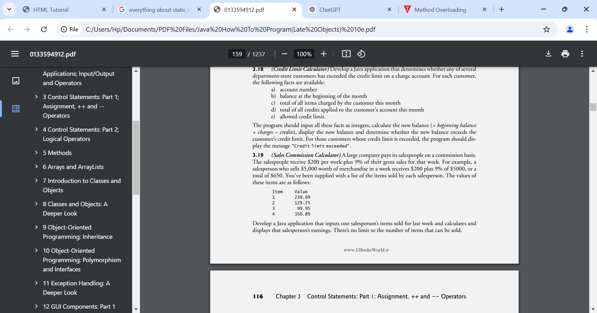

Develop a Java application that inputs one salesperson’s items sold for last week and calculates and displays that salesperson’s earnings. There’s no limit to the number of items that can be sold.
Answer:
The user enters an item number (1 to 4) and the quantity sold. Entering -1 ends the input, so any number of items is allowed. Earnings = $200 + 9% of gross sales.
import java.util.Scanner;

public class Commission {
public static void main(String[] args) {
Scanner input = new Scanner(System.in);
double grossSales = 0.0;

System.out.print("Enter item number 1-4 (-1 to finish): ");
int item = input.nextInt();

while (item != -1) {
double value;

switch (item) {
case 1: value = 239.99; break;
case 2: value = 129.75; break;
case 3: value = 99.95; break;
case 4: value = 350.89; break;
default: value = 0.0;
}

if (value == 0.0) {
System.out.println("Invalid item number.");
} else {
System.out.print("Enter quantity sold: ");
int quantity = input.nextInt();
grossSales += value * quantity;
}

System.out.print("Enter item number 1-4 (-1 to finish): ");
item = input.nextInt();
}

double earnings = 200.0 + 0.09 * grossSales;
System.out.printf("Gross sales: $%.2f%n", grossSales);
System.out.printf("Earnings: $%.2f%n", earnings);
}
}

3.20 (Salary Calculator)
Develop a Java application that determines the gross pay for each of three employees. The company pays straight time for the first 40 hours worked by each employee and time and a half for all hours worked in excess of 40. You’re given a list of the employees, their number of hours worked last week and their hourly rates. Your program should input this information for each employee, then determine and display the employee’s gross pay. Use class Scanner to input the data.
Answer:
import java.util.Scanner;

public class Salary {
public static void main(String[] args) {
Scanner input = new Scanner(System.in);
int employee = 1;

while (employee <= 3) {
System.out.printf("Employee %d hours worked: ", employee);
double hours = input.nextDouble();
System.out.printf("Employee %d hourly rate: ", employee);
double rate = input.nextDouble();

double pay;
if (hours <= 40) {
pay = hours * rate;
} else {
pay = 40 * rate + (hours - 40) * rate * 1.5;
}

System.out.printf("Employee %d pay: $%.2f%n%n", employee, pay);
employee++;
}
}
}

3.21 (Find the Largest Number)
The process of finding the largest value is used frequently in computer applications. For example, a program that determines the winner of a sales contest would input the number of units sold by each salesperson. The salesperson who sells the most units wins the contest. Write a pseudocode program, then a Java application that inputs a series of 10 integers and determines and prints the largest integer. Your program should use at least the following three variables:
a) counter: A counter to count to 10 (i.e., to keep track of how many numbers have been input and to determine when all 10 numbers have been processed).
b) number: The integer most recently input by the user.
c) largest: The largest number found so far.
Answer:
Pseudocode:
Set counter to 1
Input the first number and set largest to it
Add 1 to counter
While counter is less than or equal to 10
Input the next number
If number is greater than largest
Set largest to number
Add 1 to counter
Print largest

Java application:
import java.util.Scanner;

public class Largest {
public static void main(String[] args) {
Scanner input = new Scanner(System.in);

int counter = 1;
System.out.print("Enter number 1: ");
int number = input.nextInt();
int largest = number;
counter++;

while (counter <= 10) {
System.out.printf("Enter number %d: ", counter);
number = input.nextInt();

if (number > largest) {
largest = number;
}

counter++;
}

System.out.printf("Largest number: %d%n", largest);
}
}

3.22 (Tabular Output) Write a Java application that uses looping to print the following table of values:
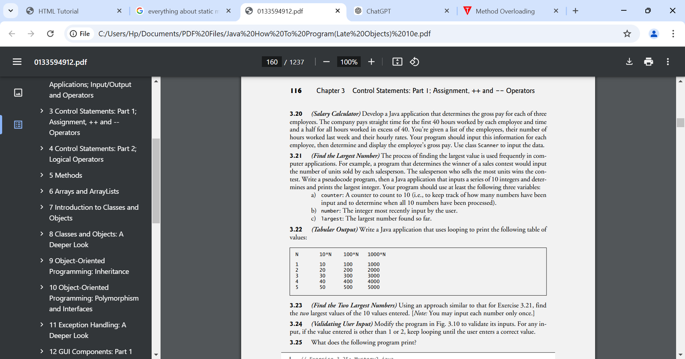
Answer:
public class Table {
public static void main(String[] args) {
System.out.println("N\t10*N\t100*N\t1000*N\n");

for (int n = 1; n <= 5; n++) {
System.out.printf("%d\t%d\t%d\t%d%n", n, 10 * n, 100 * n, 1000 * n);
}
}
}

3.23 (Find the Two Largest Numbers) Using an approach similar to that for Exercise 3.21, find the two largest values of the 10 values entered. [Note: You may input each number only once.]
Answer:
import java.util.Scanner;

public class TwoLargest {
public static void main(String[] args) {
Scanner input = new Scanner(System.in);
int largest = Integer.MIN_VALUE;
int secondLargest = Integer.MIN_VALUE;
int counter = 1;

while (counter <= 10) {
System.out.printf("Enter number %d: ", counter);
int number = input.nextInt();

if (number > largest) {
secondLargest = largest;
largest = number;
} else if (number > secondLargest) {
secondLargest = number;
}

counter++;
}

System.out.printf("Largest: %d%n", largest);
System.out.printf("Second largest: %d%n", secondLargest);
}
}

3.24 (Validating User Input) Modify the program in Fig. 3.10 to validate its inputs. For any input, if the value entered is other than 1 or 2, keep looping until the user enters a correct value.
Answer:
Fig. 3.10 is not in the file. This assumes it is the Analysis program (10 exam results, 1 = pass, 2 = fail). The inner while loop repeats until the user enters 1 or 2.
import java.util.Scanner;

public class Analysis {
public static void main(String[] args) {
Scanner input = new Scanner(System.in);

int passes = 0;
int failures = 0;
int studentCounter = 1;

while (studentCounter <= 10) {
System.out.print("Enter result (1 = pass, 2 = fail): ");
int result = input.nextInt();

while (result != 1 && result != 2) {
System.out.print("Invalid. Enter 1 = pass or 2 = fail: ");
result = input.nextInt();
}

if (result == 1) {
passes = passes + 1;
} else {
failures = failures + 1;
}

studentCounter = studentCounter + 1;
}

System.out.printf("Passed: %d%nFailed: %d%n", passes, failures);

if (passes > 8) {
System.out.println("Bonus to instructor!");
}
}
}

3.25 (Checkerboard Pattern of Asterisks)
Write an application that uses only the output statements
System.out.print("* ");
System.out.print(" ");
System.out.println(); to display the checkerboard pattern that follows. A System.out.println method call with no arguments causes the program to output a single newline character. [Hint: Repetition statements are required.]
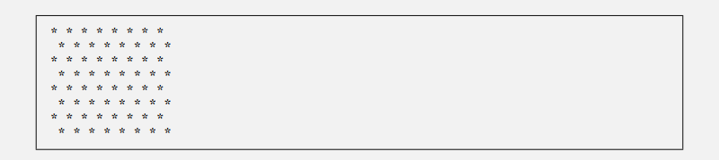
Answer:
public class Checkerboard {
public static void main(String[] args) {
for (int row = 1; row <= 8; row++) {
if (row % 2 == 0) {
System.out.print(" ");
}

for (int col = 1; col <= 8; col++) {
System.out.print("* ");
}

System.out.println();
}
}
}

Making a Difference
3.38 (Enforcing Privacy with Cryptography)
The explosive growth of Internet communications and data storage on Internet-connected computers has greatly increased privacy concerns. The field of cryptography is concerned with coding data to make it difficult (and hopefully—with the most advanced schemes—impossible) for unauthorized users to read. In this exercise you’ll investigate a simple scheme for encrypting and decrypting data. A company that wants to send data over the Internet has asked you to write a program that will encrypt it so that it may be transmitted more securely. All the data is transmitted as four-digit integers. Your application should read a four-digit integer entered by the user and encrypt it as follows: Replace each digit with the result of adding 7 to the digit and getting the remainder after dividing the new value by 10. Then swap the first digit with the third, and swap the second digit with the fourth. Then print the encrypted integer. Write a separate application that inputs an encrypted four-digit integer and decrypts it (by reversing the encryption scheme) to form the original number. [Optional reading project: Research “public key cryptography” in general and the PGP (Pretty Good Privacy) specific public key scheme. You may also want to investigate the RSA scheme, which is widely used in industrial-strength applications.]
Answer:
Encryption: add 7 to each digit and take the remainder after dividing by 10, then swap digit 1 with digit 3 and digit 2 with digit 4. Example: 1234 becomes 0189.
import java.util.Scanner;

public class Encrypt {
public static void main(String[] args) {
Scanner input = new Scanner(System.in);
System.out.print("Enter four-digit integer: ");
int number = input.nextInt();

int d1 = number / 1000;
int d2 = number / 100 % 10;
int d3 = number / 10 % 10;
int d4 = number % 10;

d1 = (d1 + 7) % 10;
d2 = (d2 + 7) % 10;
d3 = (d3 + 7) % 10;
d4 = (d4 + 7) % 10;

// swap 1st with 3rd, 2nd with 4th
System.out.printf("Encrypted: %d%d%d%d%n", d3, d4, d1, d2);
}
}

Decryption: undo the swaps first, then undo the +7 by adding 3 to each digit (mod 10). Example: 0189 becomes 1234.
import java.util.Scanner;

public class Decrypt {
public static void main(String[] args) {
Scanner input = new Scanner(System.in);
System.out.print("Enter encrypted four-digit integer: ");
int number = input.nextInt();

int d1 = number / 1000;
int d2 = number / 100 % 10;
int d3 = number / 10 % 10;
int d4 = number % 10;

// undo the swaps
int t = d1; d1 = d3; d3 = t;
t = d2; d2 = d4; d4 = t;

// undo adding 7 (adding 3 mod 10)
d1 = (d1 + 3) % 10;
d2 = (d2 + 3) % 10;
d3 = (d3 + 3) % 10;
d4 = (d4 + 3) % 10;

System.out.printf("Decrypted: %d%d%d%d%n", d1, d2, d3, d4);
}
}

3.39 (World Population Growth)
World population has grown considerably over the centuries. Continued growth could eventually challenge the limits of breathable air, drinkable water, arable cropland and other limited resources. There’s evidence that growth has been slowing in recent years and that world population could peak sometime this century, then start to decline. For this exercise, research world population growth issues online. Be sure to investigate various viewpoints. Get estimates for the current world population and its growth rate (the percentage by which it’s likely to increase this year). Write a program that calculates world population growth each year for the next 75 years, using the simplifying assumption that the current growth rate will stay Print the results in a table. The first column should display the year from year 1 to year 75. The second column should display the anticipated world population at the end of that year. The third column should display the numerical increase in the world population that would occur that year. Using your results, determine the year in which the population would be double what it is today, if this year’s growth rate were to persist.
Answer:
Figures used: about 8.3 billion people and a growth rate of about 0.83% per year (UN World Population Prospects 2024 estimate for 2026). Result: the population doubles in year 84, which is about 2110, so it does not double within the 75-year table.
public class WorldPopulation {
public static void main(String[] args) {
double startPopulation = 8300000000.0; // 2026 estimate
double growthRate = 0.0083; // 0.83% per year
double population = startPopulation;

System.out.printf("%-6s %-20s %-20s%n", "Year", "Population", "Added");

for (int year = 1; year <= 75; year++) {
double increase = population * growthRate;
population += increase;
System.out.printf("%-6d %-,20.0f %-,20.0f%n",
year, population, increase);
}

// keep growing until the population has doubled
int doubleYear = 75;
while (population < 2 * startPopulation) {
population += population * growthRate;
doubleYear++;
}

System.out.printf("%nThe population doubles in year %d (about %d).%n",
doubleYear, 2026 + doubleYear);
}
}

